Lab- AWS CLI, SDK, IAM Roles and Policies

# 114. Install AWS Cli

Install AWS cli

* Google search for link 🡪 ‘install AWS cli on mac’
* Chose the click to Amazon documentation, to install AWS cli version2 on mac 🡪
* <https://docs.aws.amazon.com/cli/latest/userguide/install-cliv2-mac.html>
* Download .pkg file 🡪 <https://awscli.amazonaws.com/AWSCLIV2.pkg>
* Install the pkg file
* Test on terminal🡪

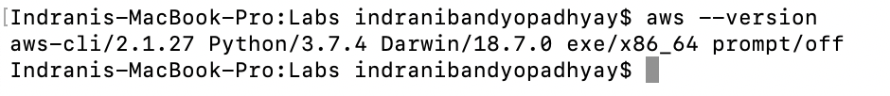

# 116. AWS CLI Configuration

## Commands to configure

* You can delete/deactivate existing AWS key ID and secret access key, then create it again later when needed. Ensure no one can access your AWS account

### Go to IAM 🡪 open the user 🡪 security credentials tab 🡪 Access keys

# 117. AWS CLI on EC2

Steps:

* Create an EC2 instance
* SSH into the instance from terminal
  + chmod 0400 <.pem file name>
  + ssh ec2-user@<public ip of ec2 instance> -I <.pem file name>
* In the console
  + Check aws –version  
    

CLI is already installed in it

* + AWS configure, but do not put any credentials in it  
    Text

    Description automatically generated
* Create AWS role
  + IAM 🡪 create Role
  + Choose service that will use the role 🡪 EC2
  + Create policy 🡪 Filter policy 🡪 search S3 🡪 AmazonS3FullAccess or AmazonS3ReadOnlyAccess 🡪 Next
  + Role name: Ec2-role
  + Role description: Allow Ec2 to make call to S3
  + Create Role
* Attach Role to EC2 instance
  + Action 🡪 Instance settings 🡪 Attach/Replace IAM Role 🡪 <select the role> 🡪 Apply
* Access S3 from EC2 terminal
  + Go to console
  + AWS S3 ls

mb = make bucket

# 118. AWS CLI Practice with S3

## cp: copy

Copy files from S3 to your computer, vice versa

rb: remove empty S3 bucket

# 121. EC2 Instance Metadata

Note:

* This is the list of meta-data for the EC2 instance
* Anytime the these is a ‘/’ in the end, it means there is more to it … .like in case of iam/ or metrics/
* The others have value

# 122. AWS SDK Overview

Exponential Backoff means if your API calls fails, we will wait twice as long as the previous call to try again. That ensures that you do not overload the API by trying it every milliseconds.